Karibu Kenya
December 2010
Molly Hanson
4 Credits

Ralph, the Giraffe
When I heard about the opportunity to go to Kenya during winter break I jumped at it. I had never imagined I’d be going to Africa, let alone with a great group of people to study agriculture. It was truly a once in a lifetime experience and I look forward to going back and exploring other parts of Africa in the near future. The chance to experience another culture and a different part of the world wooed me in and let me say, it was amazing. This is my experience in the awesome country of Kenya.
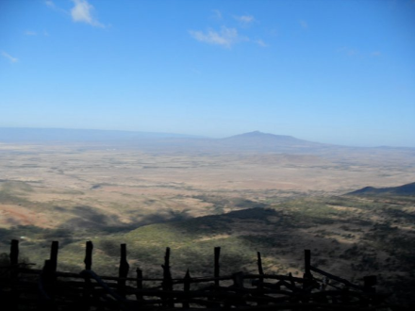
Day 1; 12/12/10- Nairobi
Our first day in Kenya was spent in the enormous city of Nairobi. Naturally our luggage didn’t make the plane change at the airport so most of us were outfit re-wearers, got to love being in the same clothes for three days in a row and two long plane rides later… not. We visited the Nairobi Animal Orphanage where we saw cheetahs, lions, ostrich, caribou, leopards and a few other exotic animals. As we were walking around somehow the opportunity came about to pet a few of the cheetahs for 500 shillings. Apparently it usually costs 40,000 shillings and two weeks’ notice however things are a little different in Kenya and everyone has their price so we got to pet the cheetahs, these huge, dangerous cats were like, well, housecats. They were purring and licking us and just laying around like it was just another day for them and not like it was this super amazing thing that we would never be able to do in the United States! When we were leaving there were Baboons everywhere, I could have sworn they were planning an attack on us. There was a little Kenyan boy out “playing” with them, he would crawl up to them and hand them a ball which I guess would earn their trust or at least make friends. After a little while of watching him all of a sudden her was petting one of them and sitting with it basically on his lap. He walked over to us after a while and I asked him if he usually does that and he said he does all the time and that his dad had taught him to. He also said that he had been bitten- a lot.
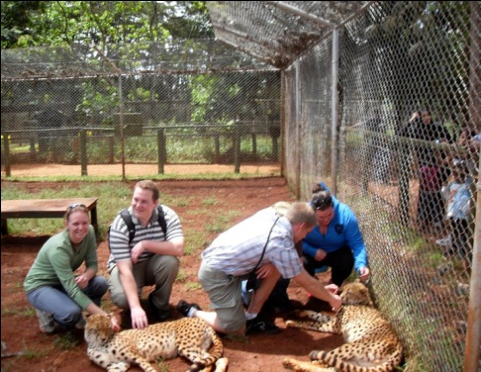
We had a crash course in Kenyan bartering. We went to one of the markets and basically got swindled. I had just gotten this new currency that I had no idea of the exchange rate, just that there were a lot of Shillings in a Dollar and there were people everywhere trying to get me to buy things. It was really overwhelming; the men would grab my hand and take me to their shop area and the women always told called to me “My sister, my sister!” They had beautiful things and when they saw a busload of “mzungus” approaching, you could see the dollar signs in their eyes. I remember one of the men asking where I was from and when I told him California his eyes lit up and he said “California! I like! You have 2-Pac!” All I could do when he said that was laugh. I ended up paying way too much for quite a few things that I didn’t really want but in that situation I had no idea what to do, looking back I’m glad I have the things I do now.

Day 2; 12/13/10- Nairobi
Our first official visit to an agricultural place in Kenya was to the Kenya Prison Farm outside of Nairobi. It took us quite a bit of time to get across the city to the prison and as we drove there we passed thousands of people. Nearly all of the people either walk everywhere or take buses or vans where they jam way too many people in there. Emmanuel told me about 80% of the 3 million people in Nairobi use the public transportation. It was amazing to see all the people living in poverty inside the city limits and how they just set up little stands for whatever they can imagine doing. I saw everything from car washes to computer charging to hair dressing on the way out of town.
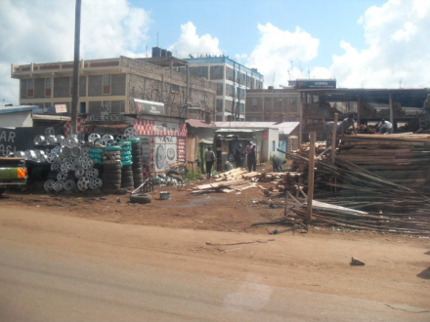
Just beyond what I can only call the ghetto we came to the prison. There were three prisons there. One was maximum security, one was a women’s prison and one was for boys 17-21 years old, when I looked at the boys I could tell some of them weren’t 17 yet, but they said since there weren’t good records or any at all in some cases, they couldn’t make any changes and they were there. We went to the one for boys, the program they go through keeps them there for four months and they are taught how to raise rabbits, goats and how to grow crops. In addition to the agricultural practices they are learned, they are taught about computers and how to make shampoo, bleach, laundry detergent, juice, jam, yogurt, and tea, basic life skills so for once they are out of prison they won’t be outcasts like most would, they will have valuable life skills. They are enabled to go back into society and have the ability to start a business and to teach other people their skills. The boys are followed up with after their four months at the prison to make sure they are staying out of trouble. They also are responsible for making their own meals. Also, if there is a boy who wants to just work on the computers or work on the farm, they are not forced to go to another activity; they can stay and work there all day.
In their little farm they have rabbits and goats and their crops. They have a liquid manure system that is a 1:2 ratio of manure to water, where they use the manure from their animals. It sits in a barrel for fourteen days to ferment and then it is used as fertilizer for the crops they grow. They have a permaculture system where they have a table with what looks like a big box on top where they have fertilizer with worms that decompose stuff in the soil and the vegetables and other organic matter that they add to the soil.
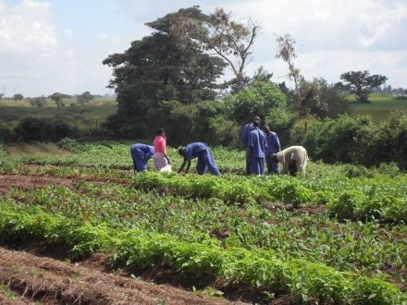
Shortly before we left the prison we all sat down in front of all the boys and introduced ourselves and talked a little and they showed us all their stuff they make, they were so proud of their goods and couldn’t wait to tell us about it and have their pictures taken. They wanted to sing a Christmas carol with us so we stood in a circle and sang Silent Night. It was a really cool moment for me, these two worlds, from opposite ends of the spectrum standing shoulder to shoulder in a circle singing a song that we all knew. After that we took a group picture and headed out to our next destination.
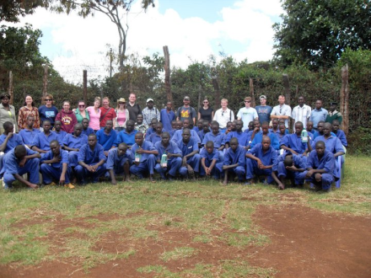
We left the prison and met Erin and Mike at the entrance (finally!) and proceeded to go to G-BIACK, which stands for the Grow Bio intensive Agriculture Center of Kenya. A big part of G-BIACK is their 50 Bed Unit. It is supposed to feed one person for one year and have enough to provide an income for them from selling produce. There is a small seed room where they keep a ton of different seeds and plant them and give them to farmers. They have a program where they give a bred rabbit to a boy and in exchange he gives two of the litter back to them and they continue to go with that process. They do a similar thing with women in a HIV/AIDS support group, they are given a bred goat and that goats baby is given to the next woman and the process is continued until all the women have one. I cannot imagine having to rely on a goat to They train people on soil quality and how to create gardens where they have a hole in the middle of a little circular bed and the hole is filled with manure and the bed is watered from there and the plants all draw water from there. They also used the permaculture and liquid manure methods. They are experimenting with intercropping with beans and corn. It hasn’t been going for very long and their preliminary results were that the beans growing in rows with the corn are showing the highest yields. There is the liquid manure system and a little transplant barn where they keep little plants to be harvested and replanted elsewhere.
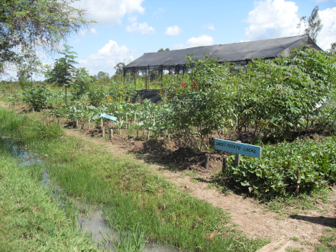

In addition to the agricultural things they have classes teaching people how to sew, weave and bead and have a library for people to use. There were several beautiful garments hanging around on the walls and a few old fashioned sewing machines for them to use. It’s amazing to see what people in other parts of the world are still using, things that we take for granted and think of as old and outdated are the things that are keeping them going. We were fortunate enough to get the chance to see a few people making bracelets and doing beadwork. We were told that they work with a lot of orphans and women. They also had a little store where they sold the goods that they made. I bought a beautiful little hand woven basket and a bracelet that one of the women had made.
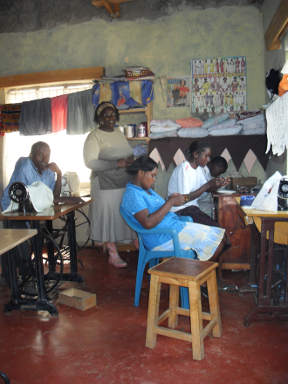

After we left G-BIACK we went all the way back across the city to another agricultural center called COSDEP. As we drove there we passed through so many different places including all the Embassies, they were really pretty. It took us a super long time to get to the next place and we saw a ton of people. When we finally got to the road to take us there it was so rough I was pretty sure that it was going to knock the fillings out of my teeth.
COSDEP stands for Community Sustainable Development Empowerment Program. As soon as we got there the people were waiting outside for us and had prepared us a meal and invited us into their home to enjoy it. When we were done the man who owned the property showed us his 950+/- chickens that were in coops on the second story of this guy’s barn, it was a pretty impressive setup. He then showed us his dairy cows. They were kept in a smallish cement pen but they looked very healthy and well taken care of. Up next were the mushrooms they grow for a profit. They keep them in gallon size plastic bag and fill it with soil and the other things that they put in there and when they have sat long enough they make cuts in the top and the mushrooms just grow right through them! He told us that from the mushrooms alone he made enough money to send his kids to school and keep his farm running. He also showed us his compost piles and pretty notable setup for his liquid manure.

Day 3; 12/14/10- Naivasha
Today we left Nairobi and went to Lake Naivasha. Our first stop was at the Flamingo Flower Farm. They had a massive setup worth millions of dollars. There are over 40 varieties of roses alone there, we were taken into one of the greenhouses where there were hundreds of blooming roses, it was so beautiful! Their primary market is the United Kingdom but they also send to Japan and a little to the United States.
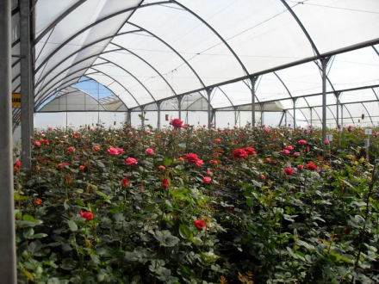
Lake Naivasha is having a lot of water issues, as in all the flower farms and farmers in the area are taking massive amounts of water out of the lake but there is a lack of tributaries and rainfall to keep up with them. Flamingo claims that they are not polluting the water or using very much of it. There is a committee, the LNGG- Lake Naivasha Growers’ Group, which was created to protect and maintain the welfare of the shrinking lake. Not only is horticulture a major industry in the area, but fishing is as well and locals use the lake to water their stock and themselves. They have a water treatment facility where the used water is treated by getting pumped through a series of tubing that removes anything in the water and filters it and it is eventually recycled back to the farm again. From the flower farm we went to Hell’s Gate and went on a stunning hike through canyons and riverbeds.

Day 4; 12/15/10- Kericho
Today we were in Kericho. Our first stop was at the tea factory where they mix the teas to flavors they prefer and then sell it to all corners of the world. It was started in 1937 and their annual production is around 9.5 million kilos, which is nearly 21 million pounds. 95% of the tea grown in Kenya is exported; this factory blends tea from eastern and western Kenya, meaning east and west of the Great Rift Valley. According to our tour guide, Kenyan tea is the best in the world. The middle-east is by far their biggest customers followed by the United Kingdom. They had thousands of big white bags that were filled with different types and varieties of tea.
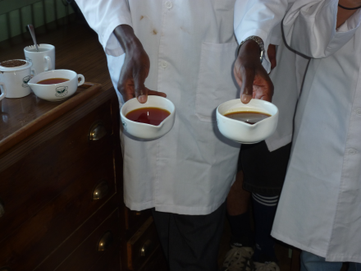
The way they mix the teas is by taste. They literally taste each different tea by the spoonful, they smell it, swish it in their mouth and then spit it back out. They never swallow it though. After they try one they follow it with water to cleanse the pallet and the tasters can only take fifteen teas at a time before their mouth is unable to take anymore. They look for acidity and differences in the sweetness, softness and bitterness. The machinery is amazing; they use a 2 million dollar machine to pack the little individual tea bags. The machinery does not have many problems because the tea is dry so it does not clog up the machine. The boxes of tea are still plastic wrapped by hand, there are women who wrap it up like a package and use this little iron to melt it just enough to get it to stick together so it won’t open while on shelves or in transport.
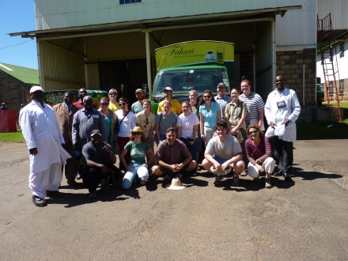
Our guide told us that the shelf life of the tea is five years but when it goes to Saudi Arabia they demand that the life say three years so they have a few issues when the tea sent to them doesn’t sell because the Saudis want the company to split the cost of the loss and they send the tea back so they are stuck with good tea with an expired stamp. They also have to stamp their tea with a “For Export” stamp because it prevents locals from getting out of taxes. They will buy the tea and say it is for export but then turn around and sell it domestically for a profit without paying taxes on it.
Before leaving they invited us to have tea with them in one of their board rooms. It was great! There is still a strong English influence in the country so having afternoon tea is very popular. We tried the different teas and most of us bought boxes of the different ones, I bought a case of the Safari tea which was the best one they had. That stuff is good.
After leaving the tea factory we proceeded to the Finlays Estate to the Kymulot Tea Plantation and factory. This particular plantation is one of many that make up the Finlays Estate. Kymulot is 6000 hectares, which equals about 14,826 acres. It was started in 1926 and the company is nearly completely self-sustainable for its almost 14,000 employees. There are schools, banks, medical, stores and housing! The fields go on for as far as you can see and they are beautiful.
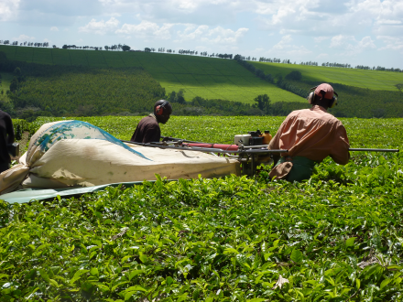
Kymulot makes a total of 25 million kilos of tea a year. They buy the leaves fresh from local farms where there are certified and uncertified leaves. The certified leaves meet standards such as labor, environmental and quality while uncertified leaves may not meet all those standards. The leaves go to them with an 80% moisture level and then they are spread out to dry to about a 70% moisture level. To assist the leaves with the drying process they use Eucalyptus leaves, you can see groves of the trees planted all around the estate. After they are dried for a while the leaves go through the process to be turned into drinkable tea. They chop up the leaves and they are sent through a series of processes to separate the fibers and unwanted pieces of the leaves so that it ends up in its purest form. When the leaves come to the end of the process they put them through, they are packed tightly into bags and are at 3% moisture.

Day 5; 12/16/10- Kitale
Today we were at Manor House. We did a ton of different activities. In the garden they taught us how they plant their beans. They use little sticks to measure the distance between the seeds and use another stick to measure how deep the seed is planted. The bed is then watered and left to grow. We also made a compost pile that they used weeds and other organic matter to build.
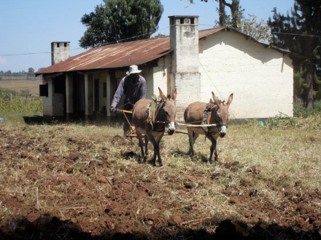
Joshua, one of the men who works at Manor House and spent a few days with us showed us how he plows with his donkey team. It was pretty funny to see everyone try to drive the team with three people while Joshua can do it by himself using vocal cues. They taught us how to do double digging, it’s the process where you take the top layer of soil and remove it, then loosen the second layer of soil and replace the top layer with fertilizer infused in it. It is a great process for small scale farming in my opinion, but not really feasible for the larger scale farming operation.

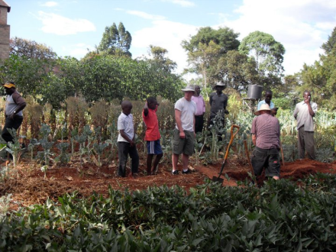
We went to Polly’s; she is one of the founders of Manor House, that evening and explored her home. She had a ton of different animals and she was so welcoming to us all. Hands down the best part of the evening was riding her camel. Holy smokes that was SO much fun. Her goat hutch was really interesting, they are elevated about 10 feet off the ground in a wooden house like thing. Most all the Kenyans have their goats in elevated pens; they say they do that because the goats like being off the ground. She also had quite a few donkeys and horses. One thing I noticed about her horses was that they looked like they needed to be wormed and have their teeth floated and they were all fairly small too.

Day 6; 12/17/10- Kitale
Our first stop today was at the Macedonia Self-Help Group. It was only about a 10 minute drive from Manor House. We went a-ways down a bumpy dirt road and when we finally got to the driveway the bus was too big to go down it so we all got out and walked. There were Kenyan children all around us just staring and following us. The entire time we were at the farm they watched us too. Joshua later told us that it was the first time that most of them had seen a white person.
.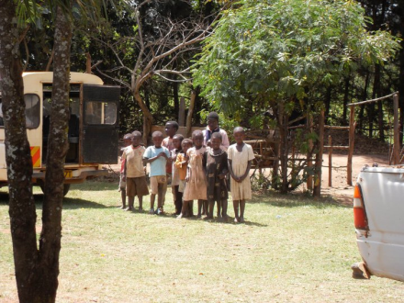
When we were at the community group the proprietor’s son was the one who told us all about the things they grow and do there. We were there at the beginning of their dry season so there wasn’t much planted. Macedonia was started in 2006 and they currently have 20 farmers that work in their little community group. It was started to educate the community in substance farming for sustainability. Like most of the Kenyan farmers, they practice bio intensive farming, which is an organic practice that gets the maximum yield from the smallest acreage. They have a solar dryer for their fruits and vegetables that was designed at Manor House and they use it to dry food so it keeps longer.
After we were shown around their farm they asked us to plant fruit trees, it was a really touching thing to see and you could see how much it meant to them. We then split up into groups of men and women and talked with each other. In the women’s group we talked about so many things. School, jobs, life, child rearing, they were just as curious about us as we were about them and it was so nice to just sit and really talk to the women without having any inhibition.
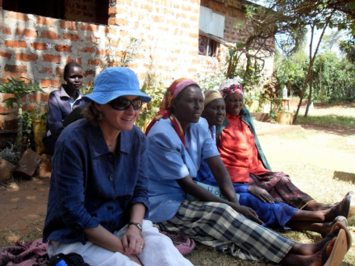
As we were leaving Macedonia the kids were back and running around and ahead of us as we went. When we got the road where the bus was parked I was amazed to see so many young children standing around looking at us. There was one little girl, probably three years old looking at me so I squatted down and put my hand out and she laid her little hand right on top of mine, it was so special to me, if there is one thing I will always remember about that trip it will be that. The kids all yell “How are you, how are you!” when they saw us on the bus or walking around. It was so funny.
Our next stop took us to a place called the Matitsi Women’s Group. They had 25 women who started the group and five of them died fairly quickly, supposedly from AIDS. They are now down to 12 active in the group, they seem to really be struggling. Weren’t there for very long, the woman who was showing us around seemed like she was a little standoffish and like she didn’t really want us there. Of all the places we visited on the trip, this one made me the saddest. It was like they couldn’t get it together even though they were really trying to and working hard to get it going. The fun part about this place is that we had to walk pretty far to get to it and there were kids everywhere around us! I loved talking their picture and they were so happy to see us. They love having their picture taken and they all wanted to see it afterwards. They would laugh and laugh after seeing themselves on the screens.
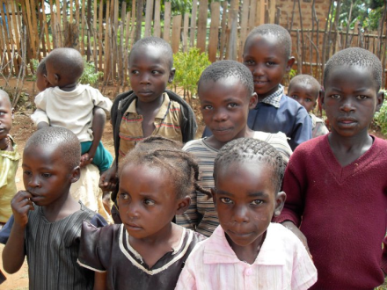
Our last visit that day was to the Kileli farm. It was so hot by the time we got there! It was established and run by Manor House graduates. The man who is in charge of it is a friend of Emmanuel’s from childhood. They showed us their 50 bed unit and all the different crops they had. They also had a few different varieties of banana trees. To water their beds they have a terracotta pot buried in the soil so that just the opening is exposed and they fill it with water and the plants draw from that. Again, there were so many kids around and they all wanted their pictures taken. After taking most of their pictures and showing them all and having them grab my hand and camera I made the discovery that one of them had pinkeye. Needless to say I was a little worried I’d get it too so as soon as we got back to the bus I sanitized all my stuff hard core. Before we left though they invited us into their brand new office and gave us all drinks and showed us diagrams of their planting processes and the different plants they have.

Day 7; 12/18/10- Kitale/ Nairobi
On our last day in Kitale we stopped at the Olaf Palme Agroforestry Centre. It is owned by Sweden and it provides indigenous trees to locals. There were hundreds of little trees to take and all of them were planted on sight. We walked through them and saw many of the indigenous trees to Kenya and the local area. Many of them had meanings or cures for different problems. There was one for if you had a sore throat you could chew on its bark and it would sooth the pain and another they people go and sing to if they have a problem or issue and it supposedly has the power to fix things.

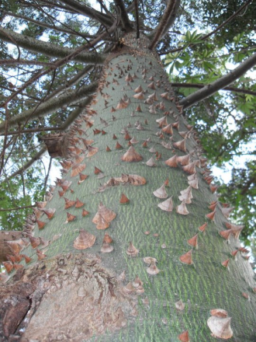
After we left the agroforestry centre we went to the airport. This airport is one for the books. It is basically two little rooms, one for waiting and the other is security and a bathroom. I thought it was kind of funny; we could never get away with something so relaxed here in the US as it was there.
We flew back to Nairobi and stayed the night at Eshel Gardens before talking off for our amazing safari. It was nice to just chill for a little while before heading back out. I went on a walk that night with a few other people and took pictures of the beautiful flowers and people and scenery. I just about jumped up a tree when a guard dog ran up and started barking at us though, talk about a heart attack. Holy cow.

Days 8-10; 12/19/10-12/21/10- Massai Mara
After driving for hours in our awesome safari vans we finally got to our hotel. It was so cool. We each had little tents that when you walked inside they were hotel rooms, totally deceiving from the outside. I was really surprised to see all the tourists on safaris from all over the world. I met people from Sweden, the US, basically all over Europe and a bunch of people from India and the Middle East.
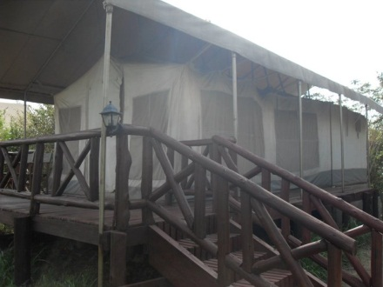
Our game drives were great. We saw so many different exotic animals! On our first day we took a short drive right after we arrived at the area, it’s basically a free-for-all out there. You can drive anywhere and there are pretty much no off limits areas.
The animals we saw were stunning. There were a lot more elephants than I thought there would be. Out of the “big five”- elephants, rhinoceros, Cape buffalo, leopard and lion, we saw everything but the leopard. The “big five” got their nickname by being the most dangerous for hunters to hunt on foot. Supposedly the leopard is rarely seen. In addition we saw cheetahs, a ton of different deer looking things, a golden cat, an eagle, hippos, zebras and so many more. While driving around the beginning of the second day all of a sudden we came upon a runway. It was pretty legit in my opinion. I’d totally fly to Massai Mara for my holiday on my private jet and land on a dirt runway while watching zebra run and elephants graze out the windows.
On the second day a few of us went to the Massai village to see the people. They greeted us with the men’s dances which included a jumping one which out white boy failed at miserably, but props to them for trying. For that one, the guy who can jump the highest gets the most girlfriends and gets to wear different wraps. They all wore red too; they said it was because the lions were afraid of it so that was their reasoning behind it. They did chants and surrounded us and all of a sudden I had something on my head and it was this huge hat made of goatskin that was part of the welcome ceremony.
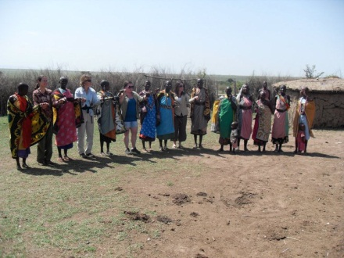
When the men were done we went inside their village that is surrounded by bushes with wicked thorns on them so it will keep their cattle in and the lions out. They have little huts made of sticks and cow manure mixed with dirt where they live and they place them in a circle around the perimeter of the fence. The women started gathering around and asked the women to join them. We all joined hands and swung them back and forth and they sang something and then we went in a single file line and gave a high-five to all the men… turns out it was a fertility dance. After we did our little dances they showed us how they start a fire using sticks and elephant dung, it was pretty impressive. We were split up into two groups after that and we went to look in their little huts. It was so smoky in the one I was in and little and dark. The parents sleep on a bed made of small sticks covered with rawhide and the kids sleep in this itty-bitty room off the “kitchen.” One of their staples in their diet is cow blood that they mix with milk, when Steven (our guide) asked if we would like to try some we were all quick to decline. After they were done showing us their village they took us to an area they had set up to sell things. They had beautiful handmade jewelry and all kinds of different Kenyan stuff.
When we were ready to go we went back out to the vans and one of the drivers had left the radio going the entire time we were at the village so the battery had died. Nearly the funniest thing I have ever seen was a bunch on Massai warriors pushing our safari van to get it started again. As we were waving goodbye Steven yelled to me “You stay here and be my second wife!” I was shocked and just kept smiling and waving and he yelled it again to which I replied through laughter “Maybe next time!” Before heading back to the hotel our driver took us to see a family of cheetahs resting in the shade. He told us that he had seen them several months before when they were just born nearly 40 kilometers away.
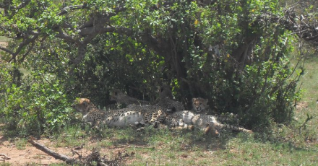
The next day we left to go back to Nairobi to catch our flight home. I slept almost the entire way from Massai Mara to Nairobi and then the entire flight to London and then from London to San Francisco. I had a wonderful time in Kenya and learned so much. Thank you for providing the opportunity for us to experience something that we may have otherwise never have gotten the chance to.

